Workshop with Wendell Beavers and Erika Berland
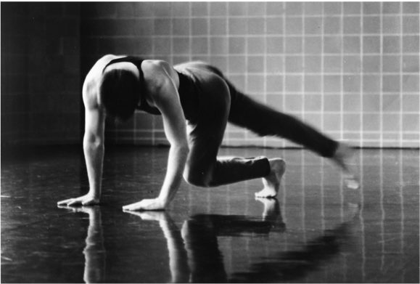

May 19-24, 2019
at Naropa University, Boulder CO

7th Annual Somatic Training for the Performer Workshop
******
2019 SPECIAL FOCUS:
THEORY AND PRACTICE OF DEVELOPMENTAL TECHNIQUE ™

An in depth study of the developmental movement patterns, the underlying reflexes, and their relationship to the anatomical systems with applications to creating original movement, choreography and physical dramaturgy
With
Wendell Beavers, Founder of Naropa University's MFA Theater; Contemporary Performance Program Founding Faculty of NYU's Experimental Theater Wing
and
Erika Berland, founding faculty of Naropa's MFA, Certified Practitioner of Body Mind Centering(R), somatic educator and meditation instructor.

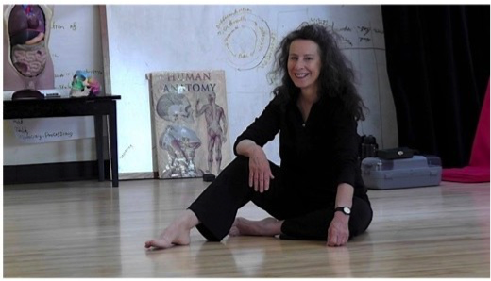

Information and Registration:
beaversberlandworkshops.com
somaticperformer@gmail.com

